**Simple Malware Scanner Using Defender (Anti-virus)**

**LAB MANUAL**

**Installation and Configuration of Computer Anti-Virus**

**Index**

1) Lab Objective------------------------------------------------------------------------- 3

2) Lab Scenario--------------------------------------------------------------------------- 3

3) Lab Task ----------------------------------------------------------------------------------3

5.1: LAB-I Downloading and installing windows updates.

5.2: LAB-II First time scanning for viruses.

**Lab Objective: Objective of this lab is student should download and install Antivirus. Scan the computer for malware and unwanted threats, remove or quarantine. It is one of the security controls for securing your computer.**

**Lab Task: Download AVG free antivirus from AVG antivirus site, install and scan computer.**

**Lab Scenario:**

Install Windows 10 operating system with minimum 2 GB of RAM and 50 GB of free space in the hard disk. Prerequisites Following are the hardware and software perquisites that are required for setting up the Lab.

HARDWARE & SOFTWARE REQUIREMENTS

• Computer / Laptop *

• 4GB RAM * (At least 2 GB)

• Hard drive with at least 50GB Free space

• Windows 10 (OS)

**Installation of Antivirus AVG**

1. Open Web Browser Search “Avg antivirus free”
2. Then Click on 1st Link
3. You will redirect to a avg web page 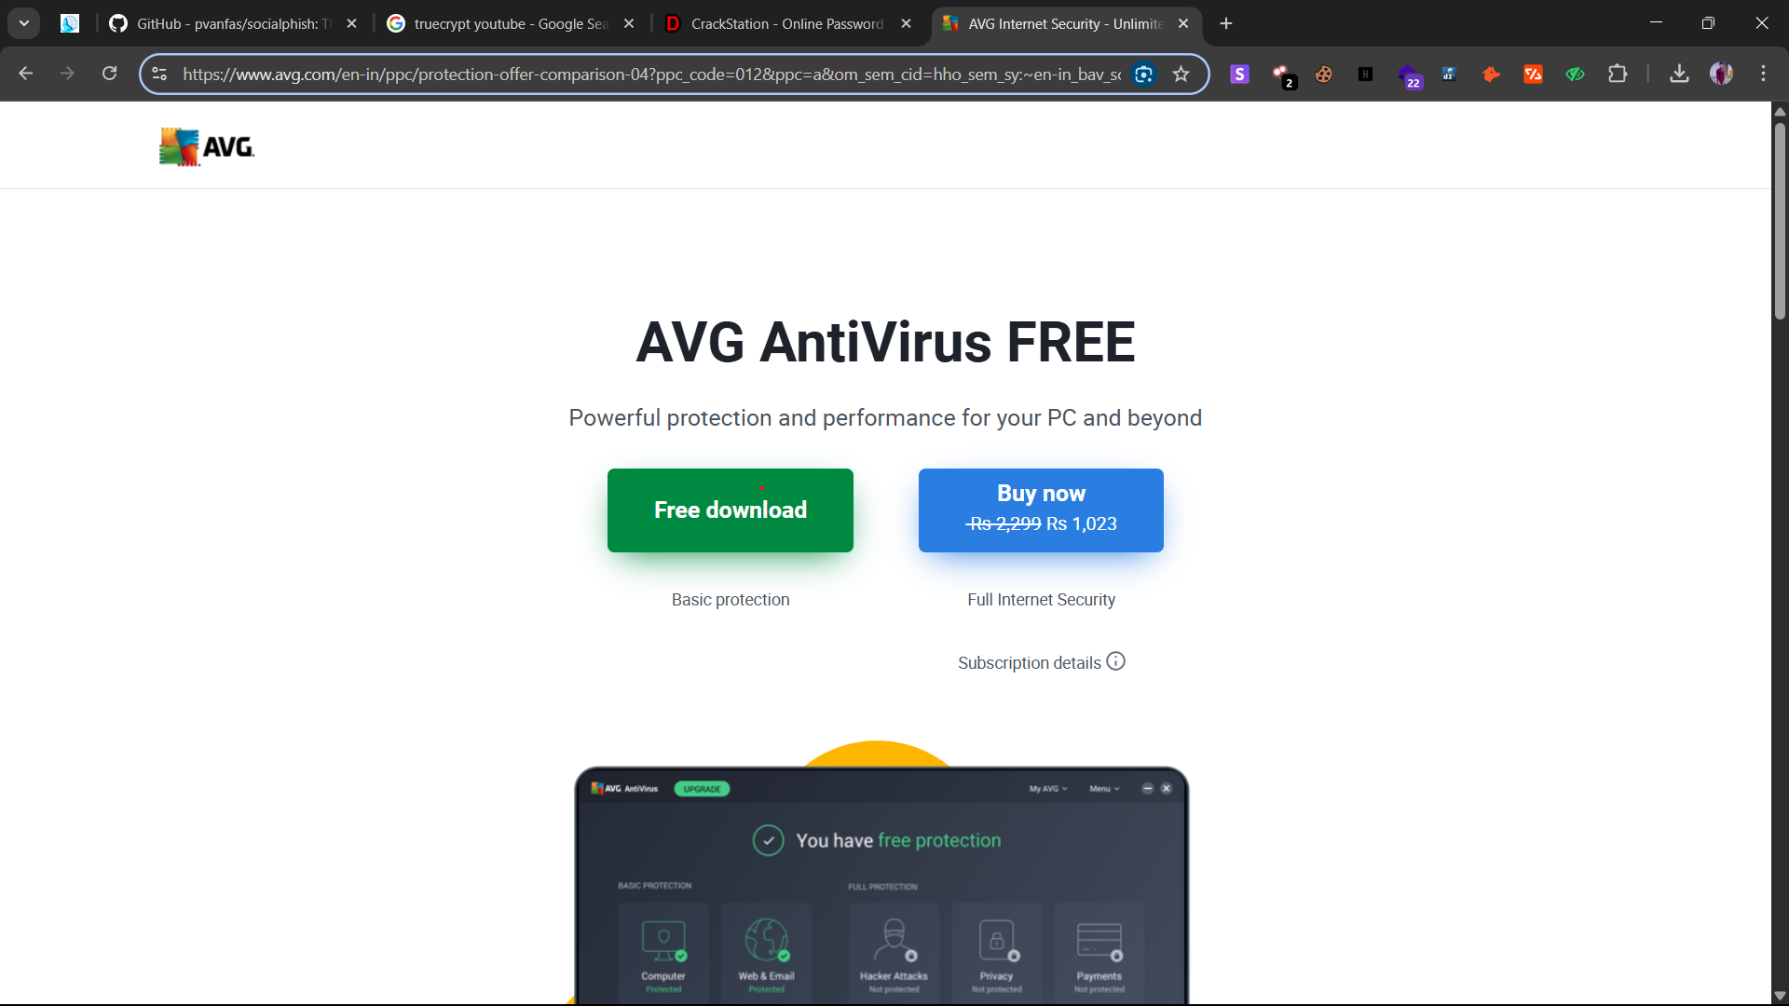
4. Click on free download
5. Select AVG setup.exe and double click.

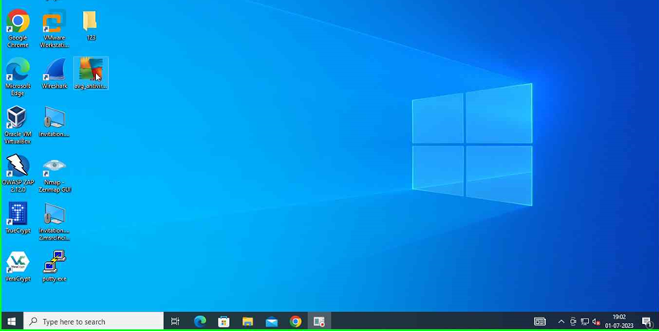

2)It runs setup of AVG antivirus installation.

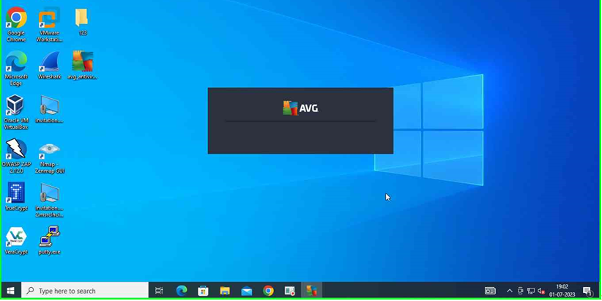

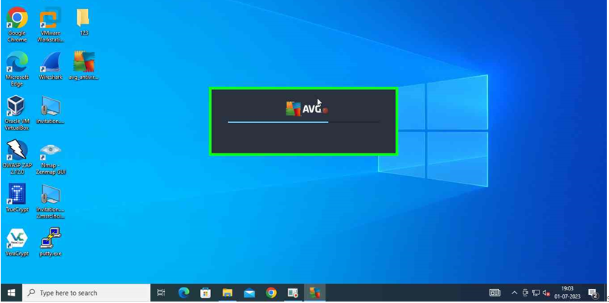

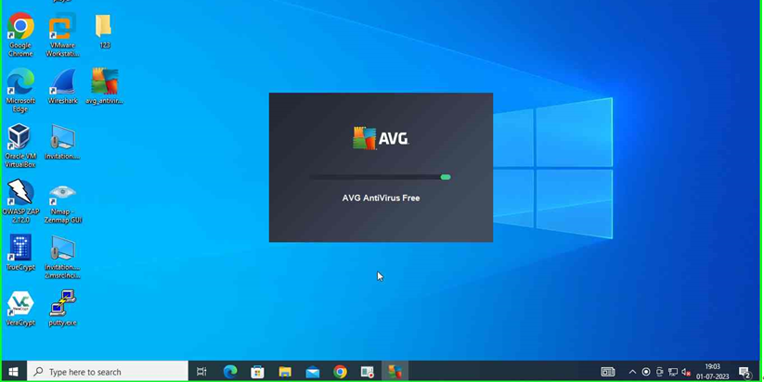

1. Select install for installation.

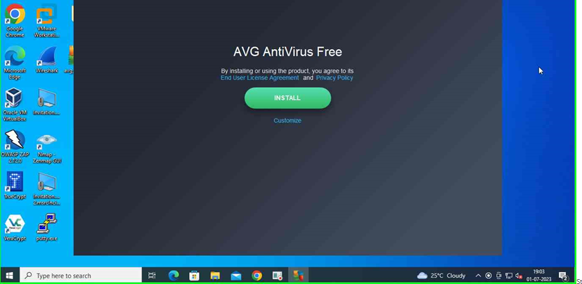

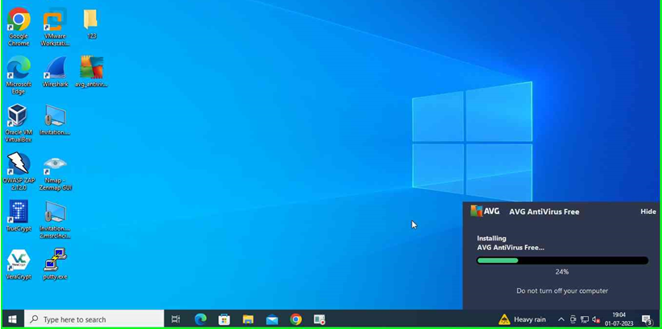

1. Complete installation and start first scan on computer.

**5.2 Scanning computer for virus and malwares by using AVG**

**Antivirus**.

